**1.GITHUB link**

[**https://github.com/ashwin31081999/demo**](https://github.com/ashwin31081999/demo)

**2.Application can be accessed by the ip address**

[**http://65.2.166.123:3000/**](http://65.2.166.123:3000/)

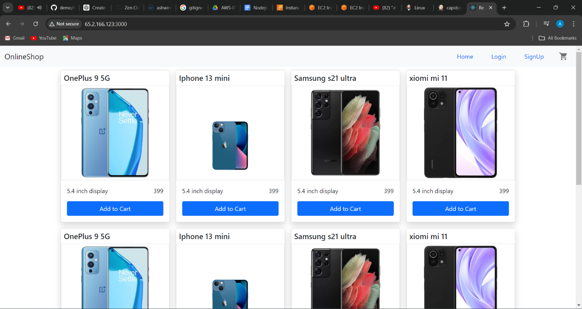

**3.Jenkins login page**

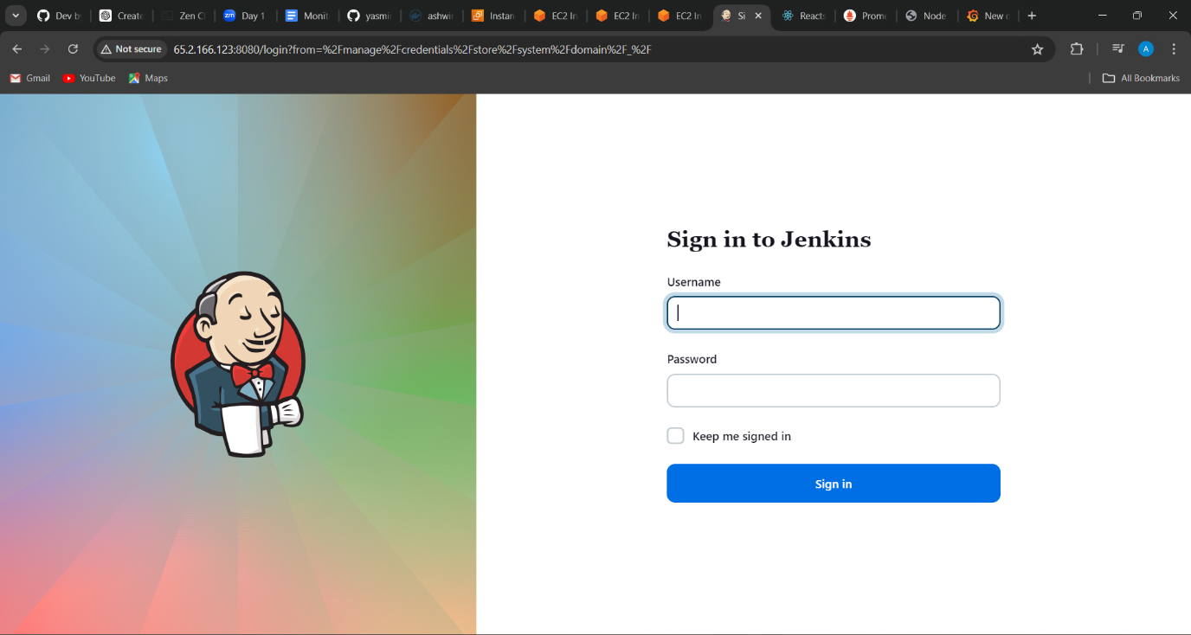

**4.Docker hub credentials added in Jenkins.**

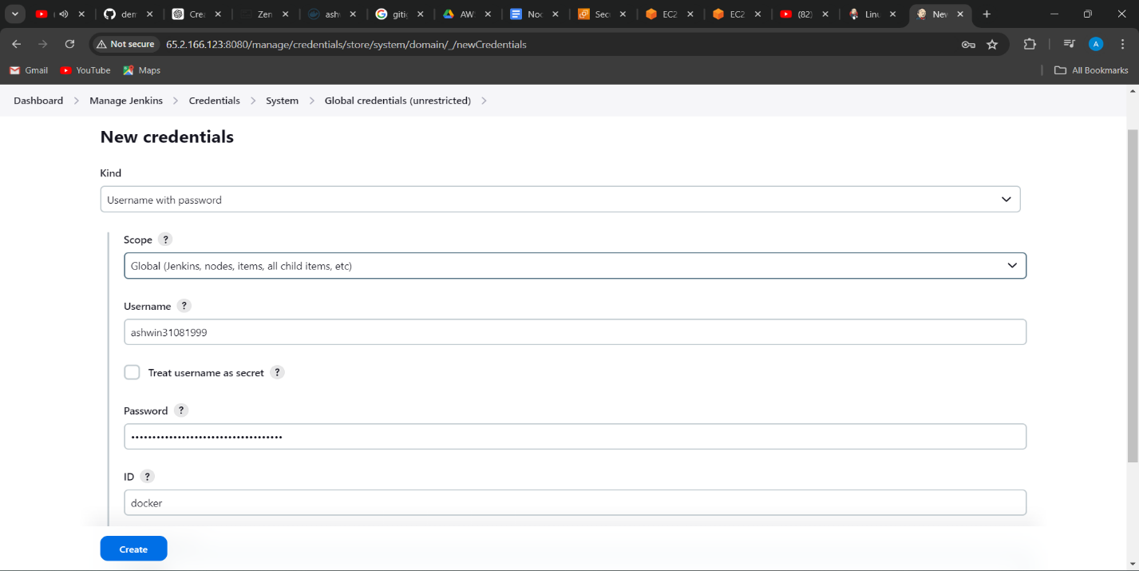

**5.Global credential.**

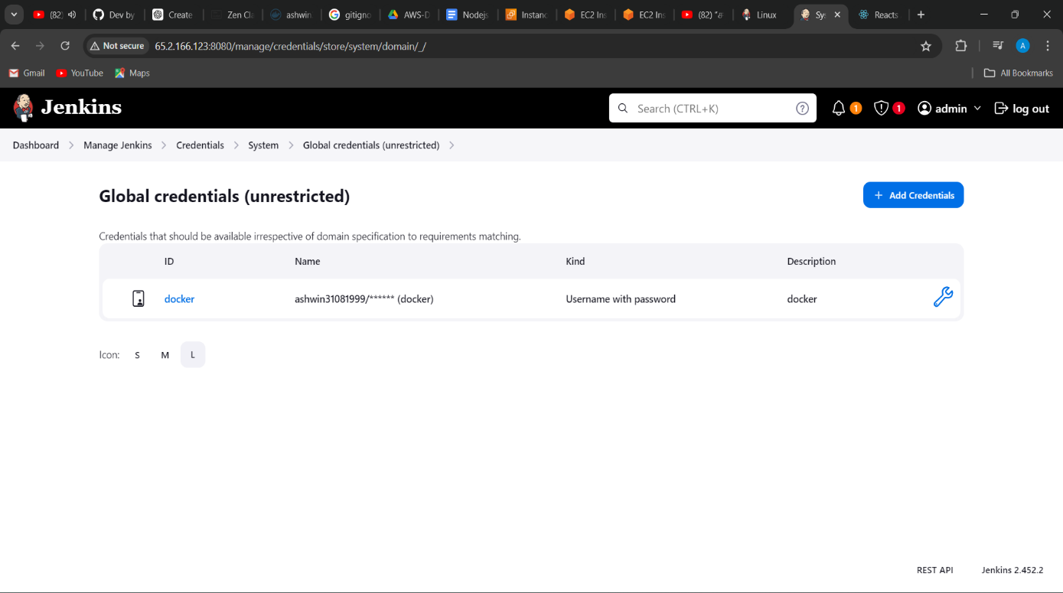

**6.****Environmental variables added -1**

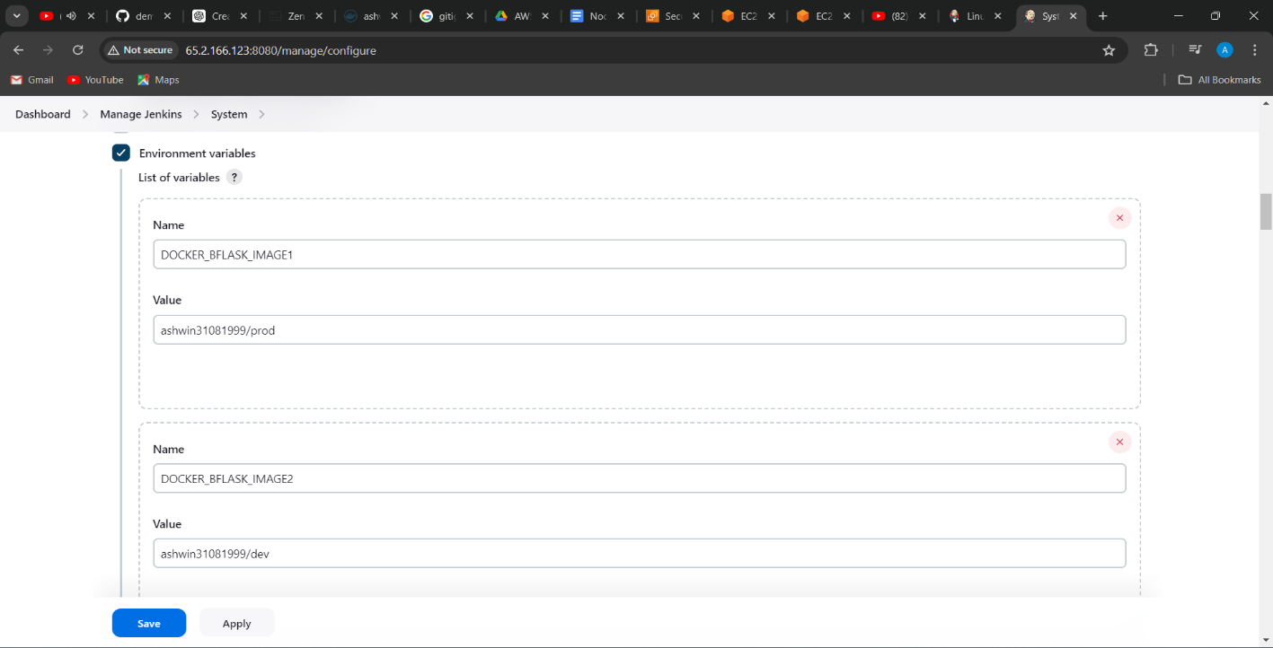

**7. Environmental variables added -2**

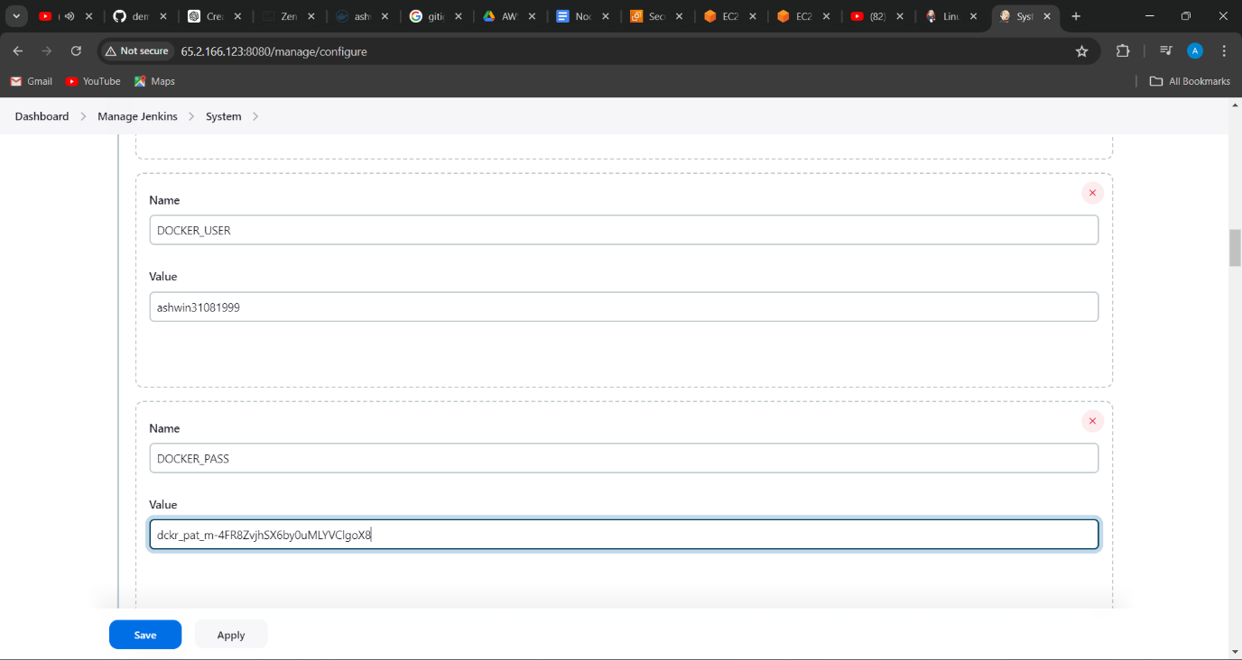

**8.Created a pipeline project in Jenkins.**

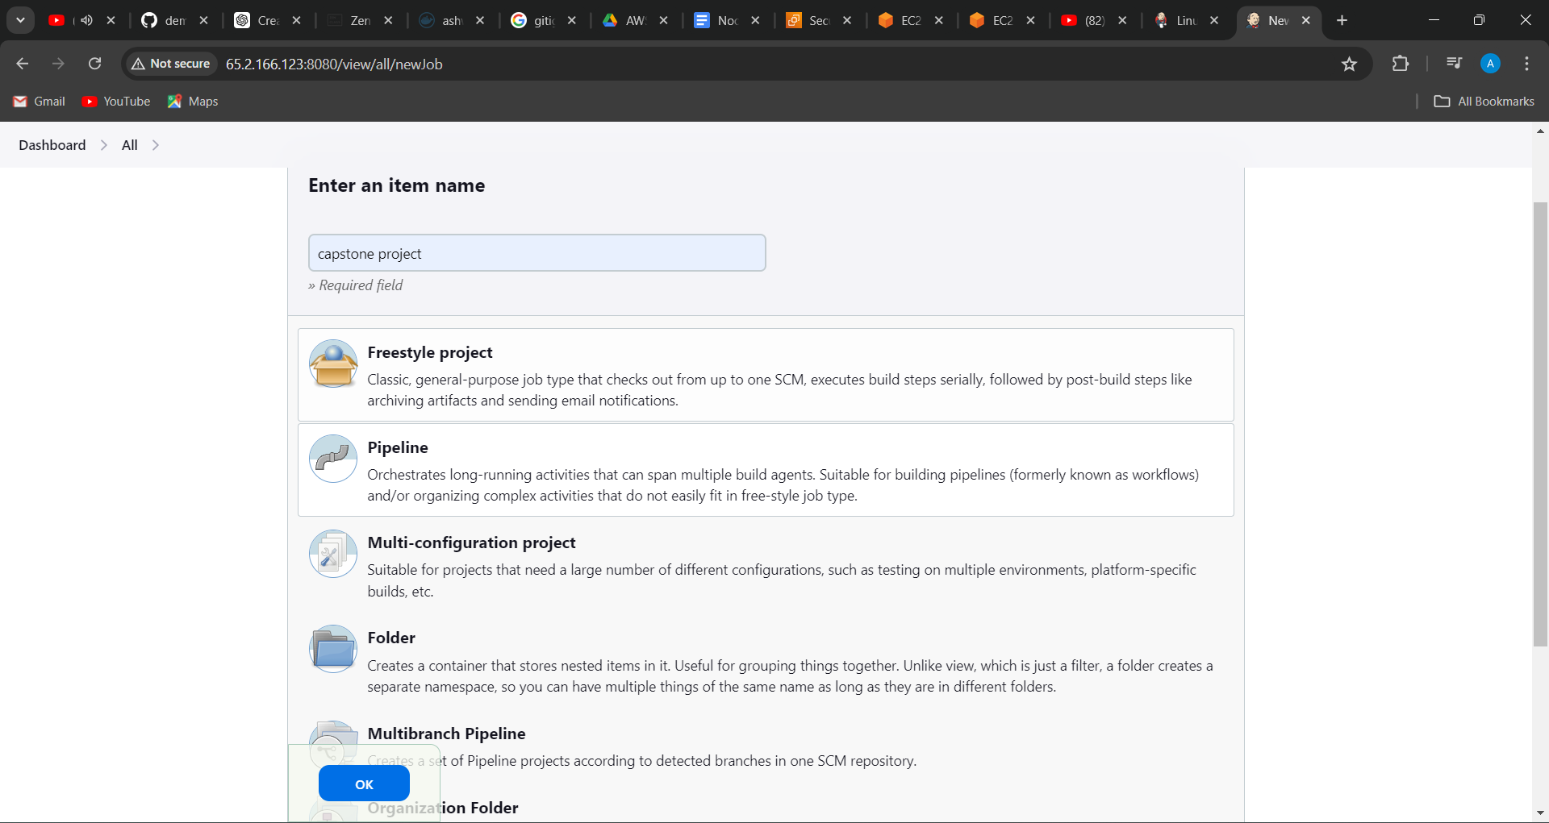

**9.****Configuring the pipeline-1**

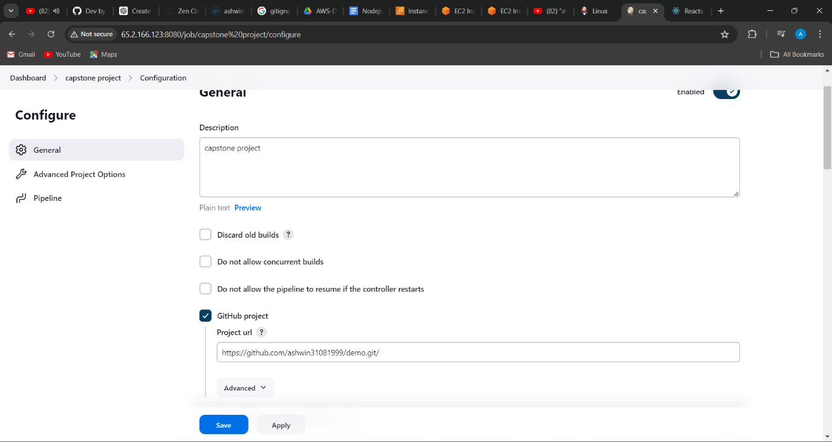

**10. Configuring the pipeline-2**

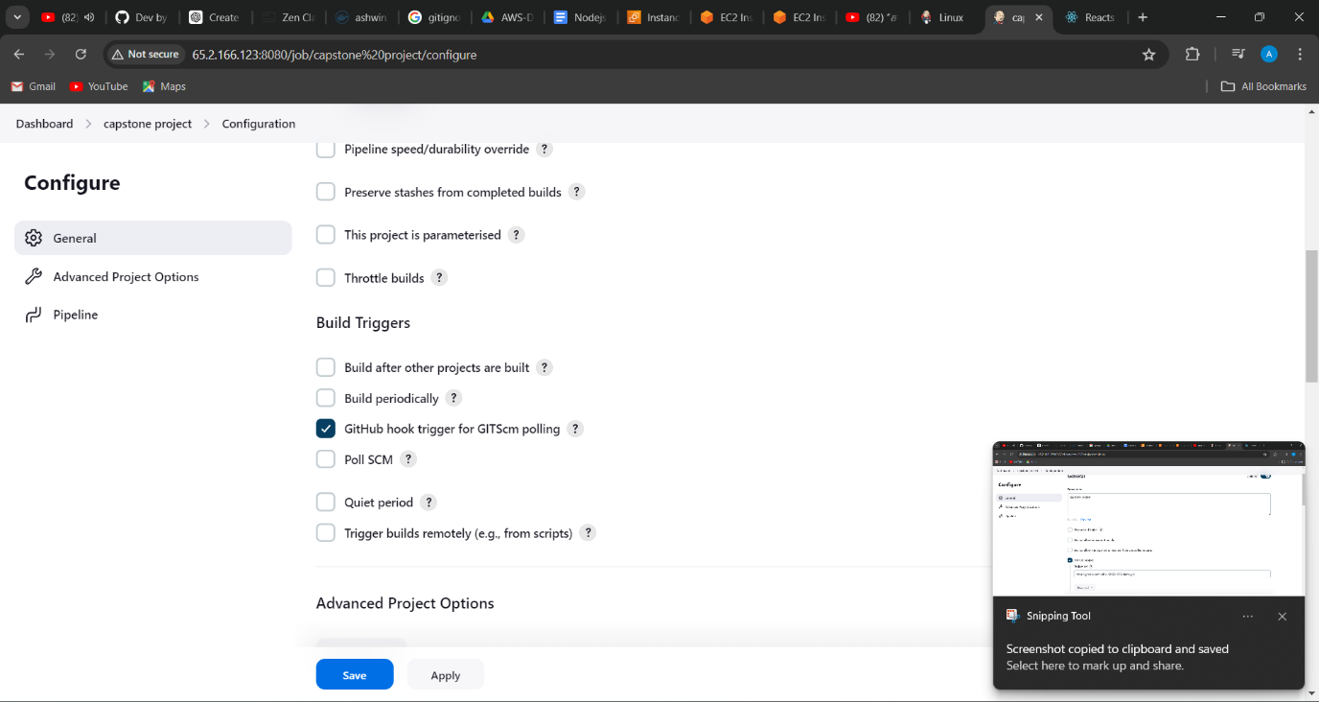

**11.** **Configuring the pipeline-3**

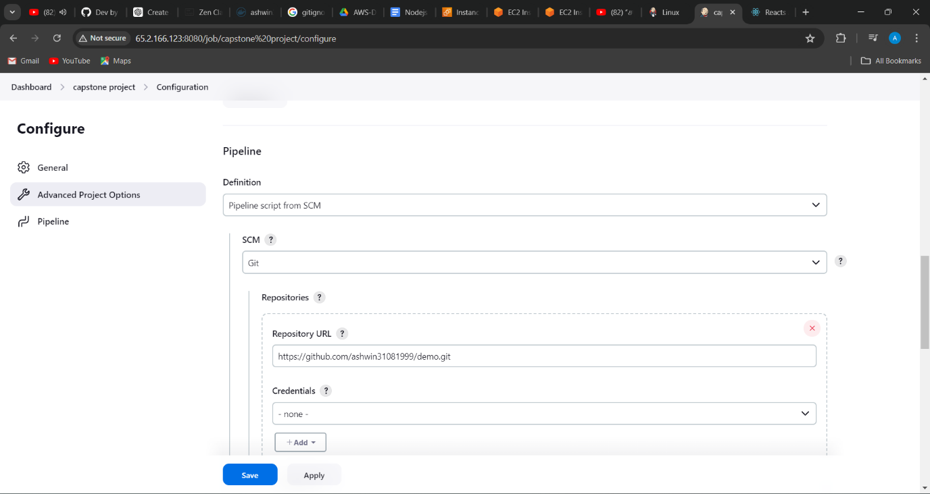

**12. Configuring the pipeline-4**

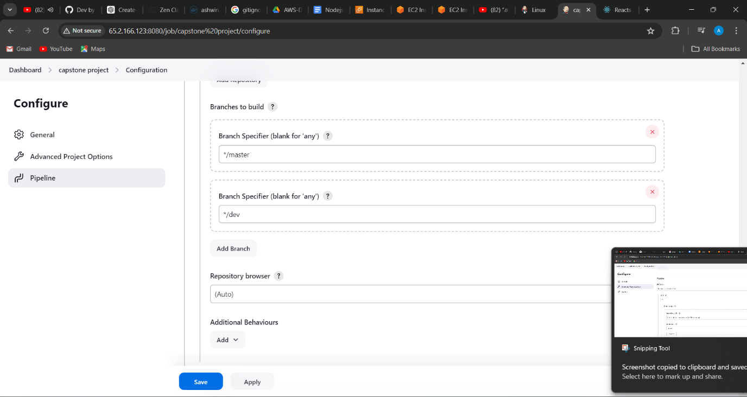

**13. Webhook configuration**

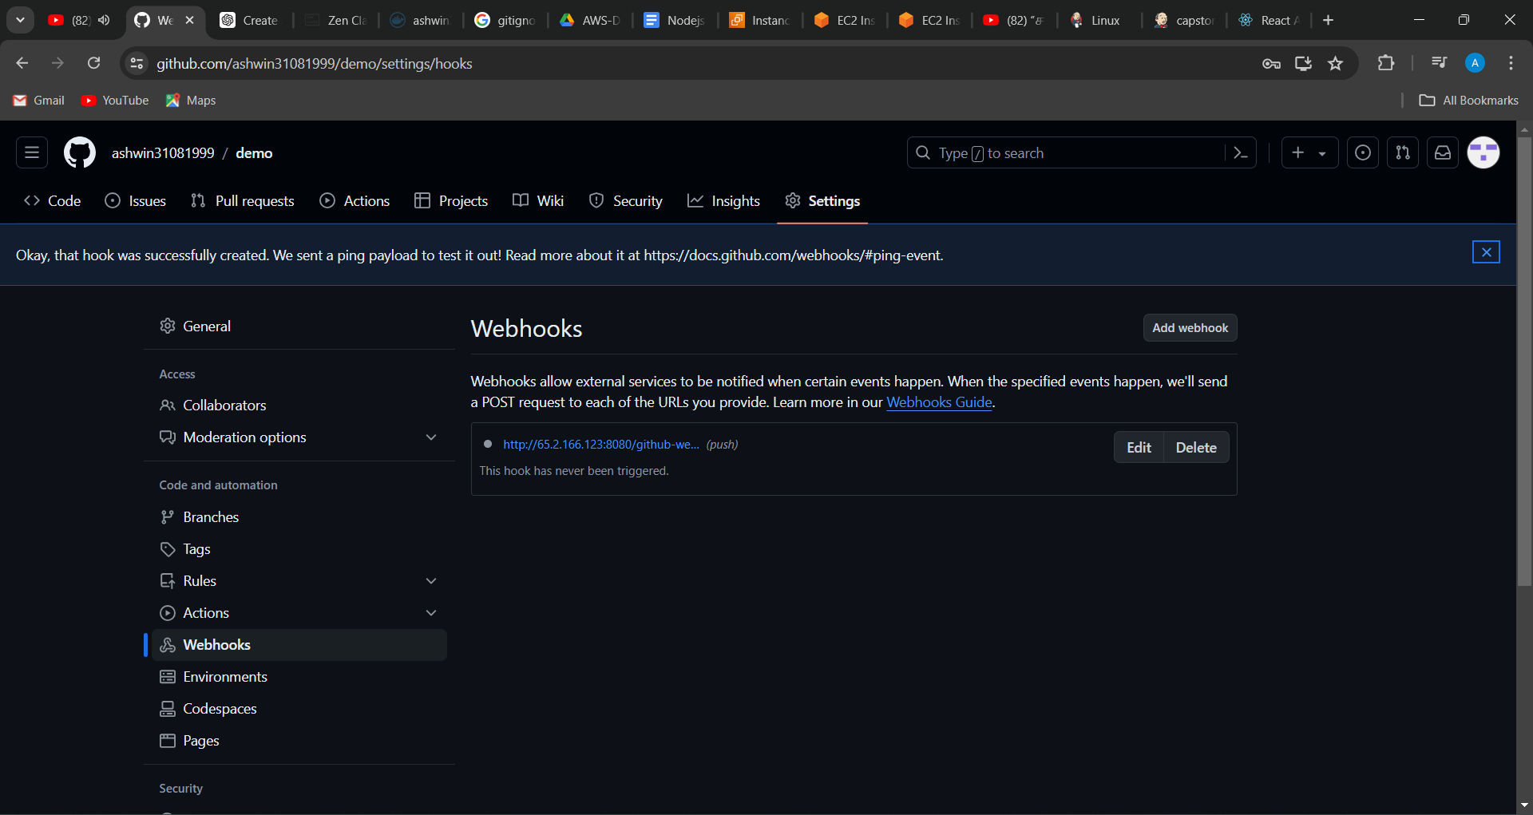

**14.** **Console output -1**

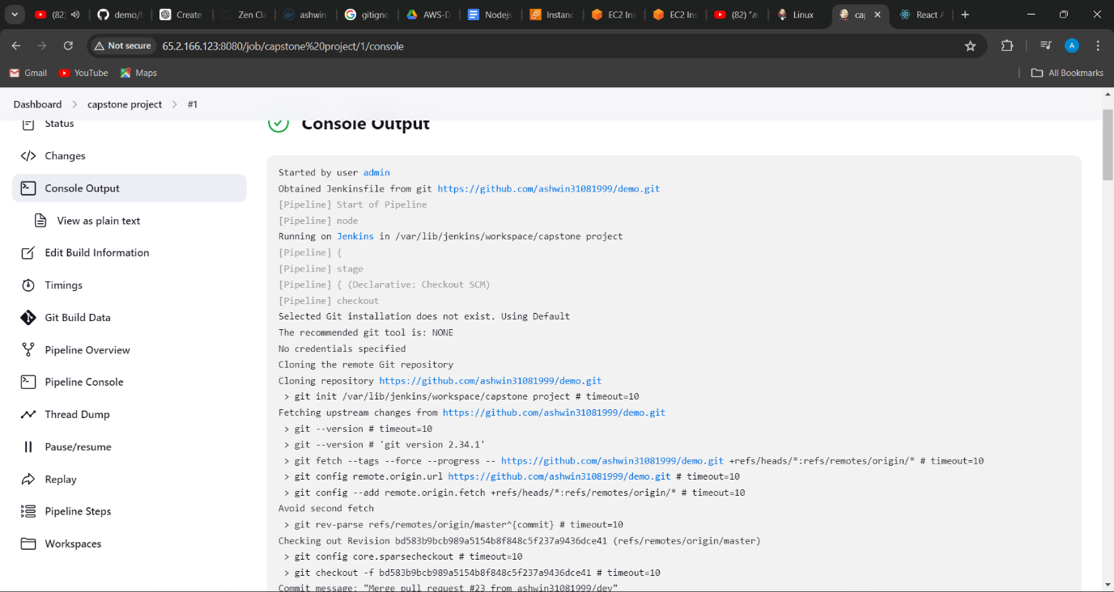

**15. Console output -2**

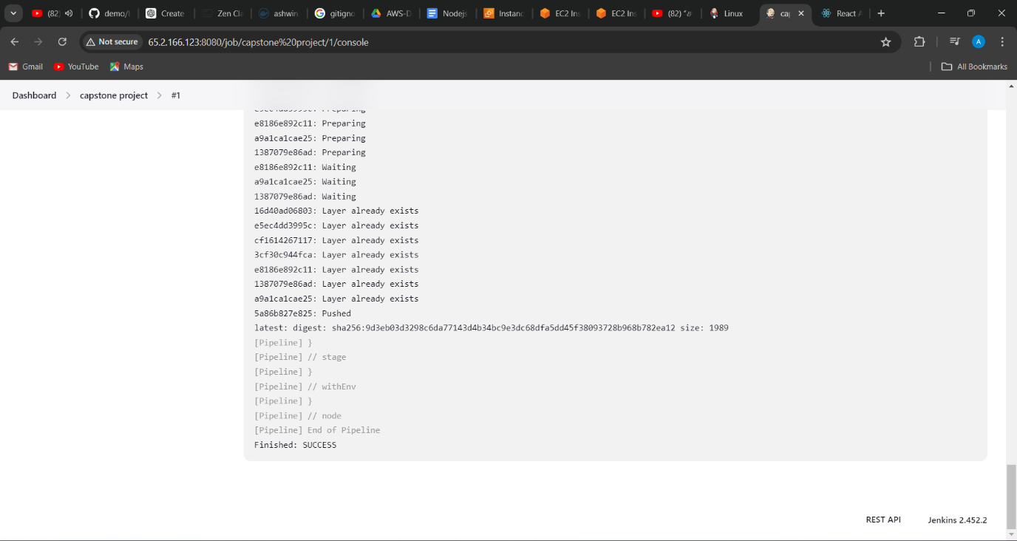

**16. Stages output**

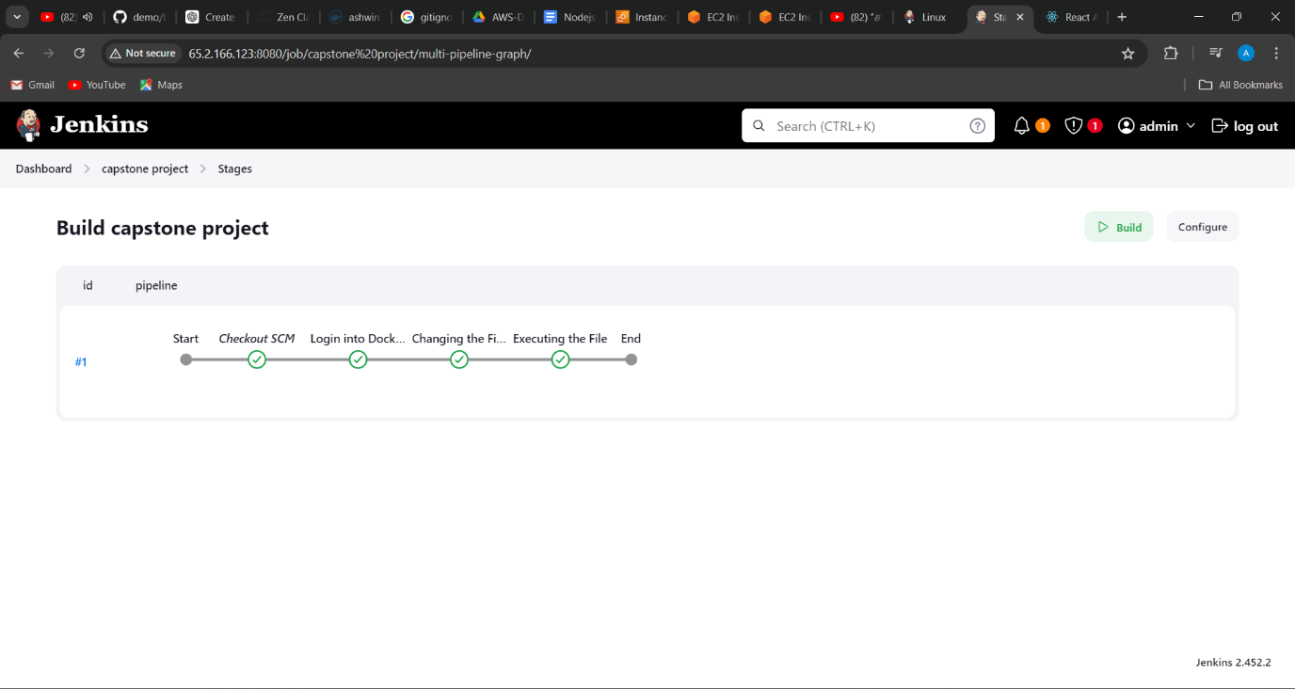

**17.EC2 machines created**

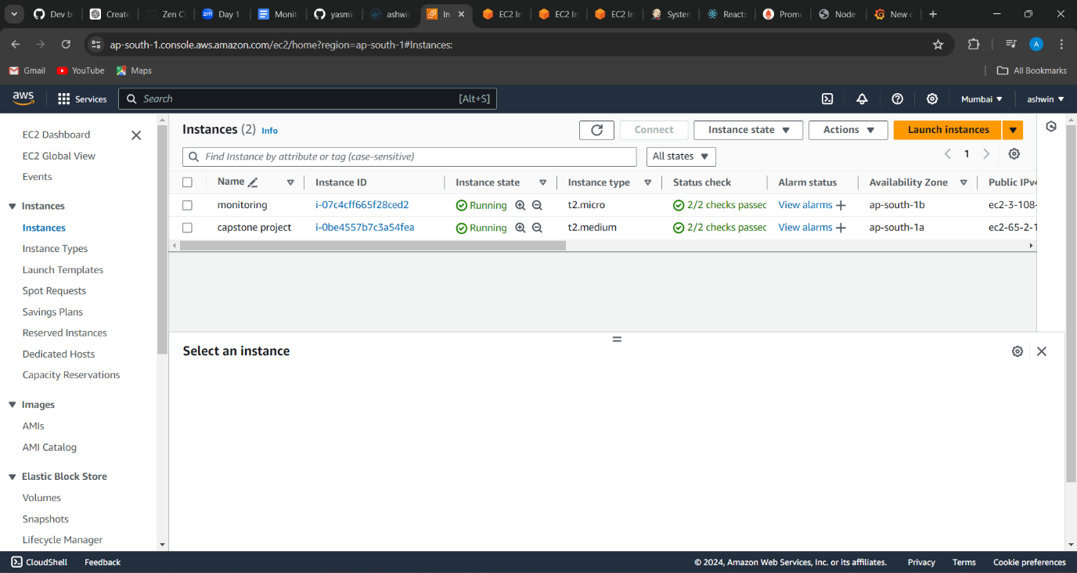

**18. Security group configuration**

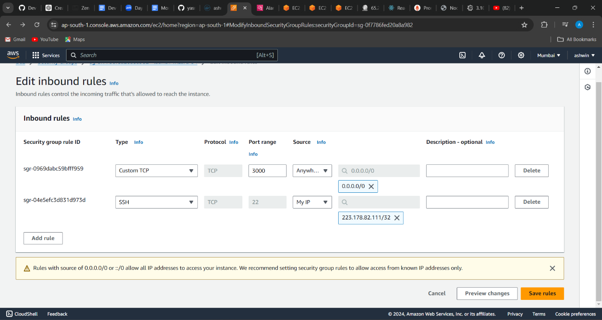

**19. Images and containers created**

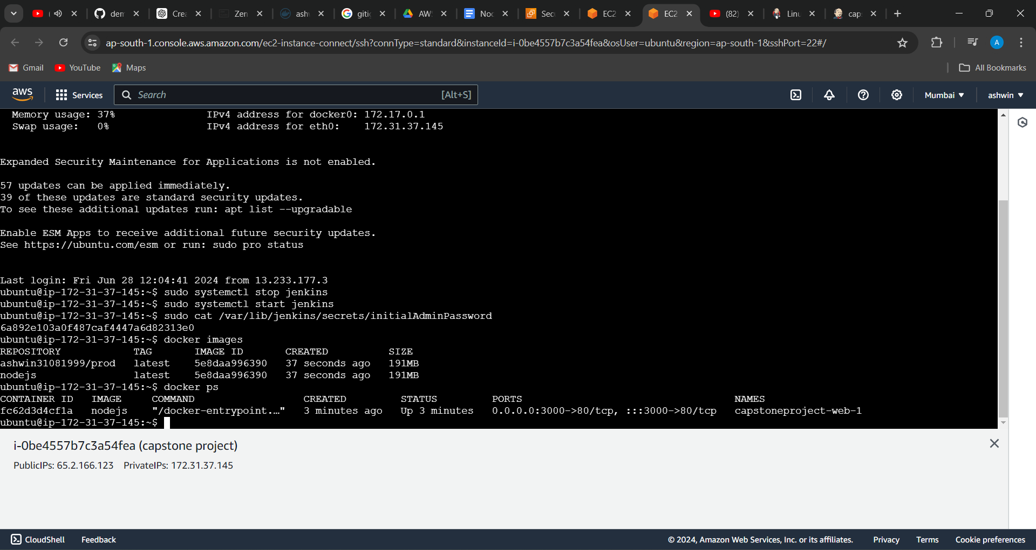

**20. Images pushed to docker dev repo**

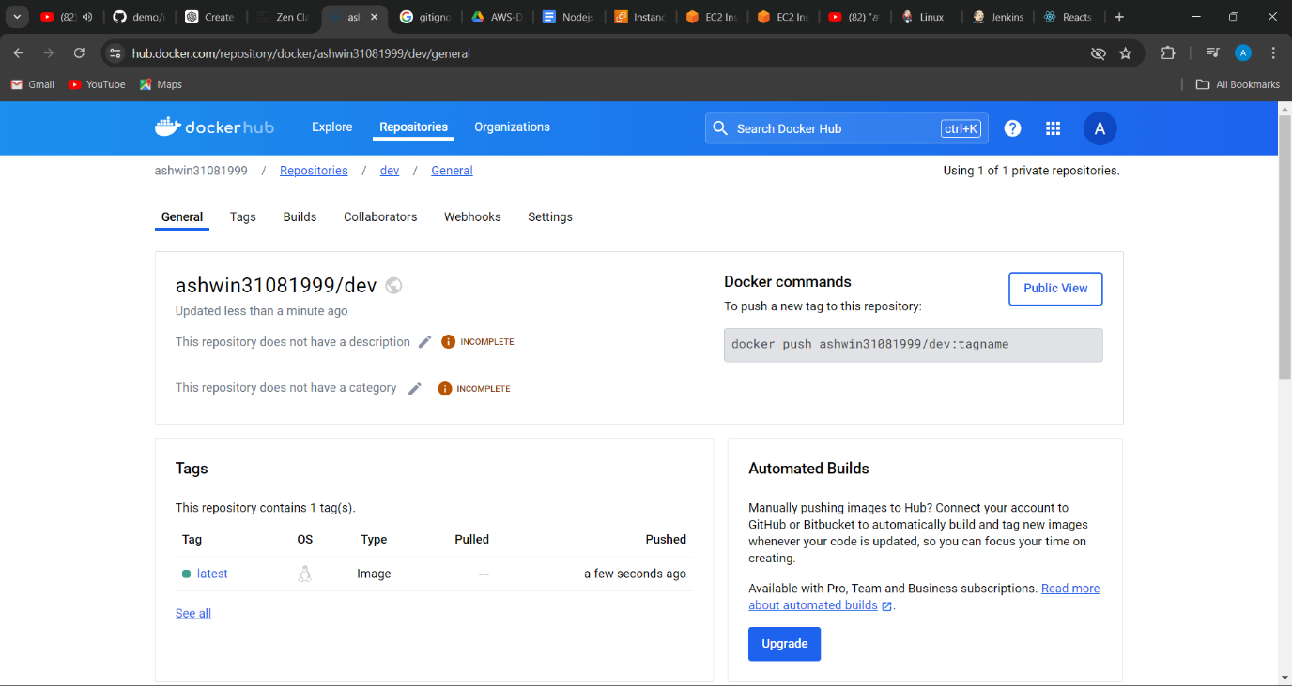

**21. The changes merged to master repo in git**

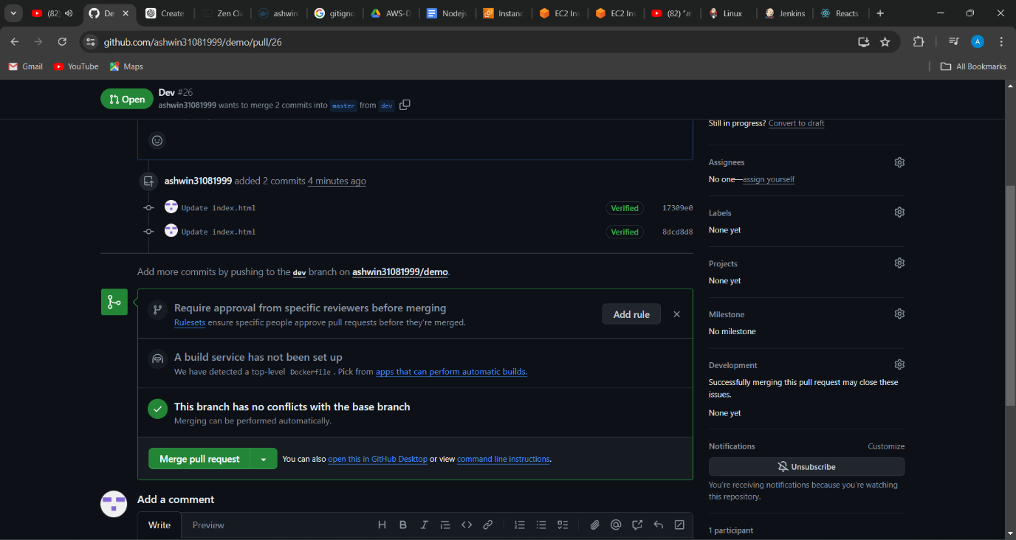

**22. After second run the image is pushed to prod (private) repo in docker**

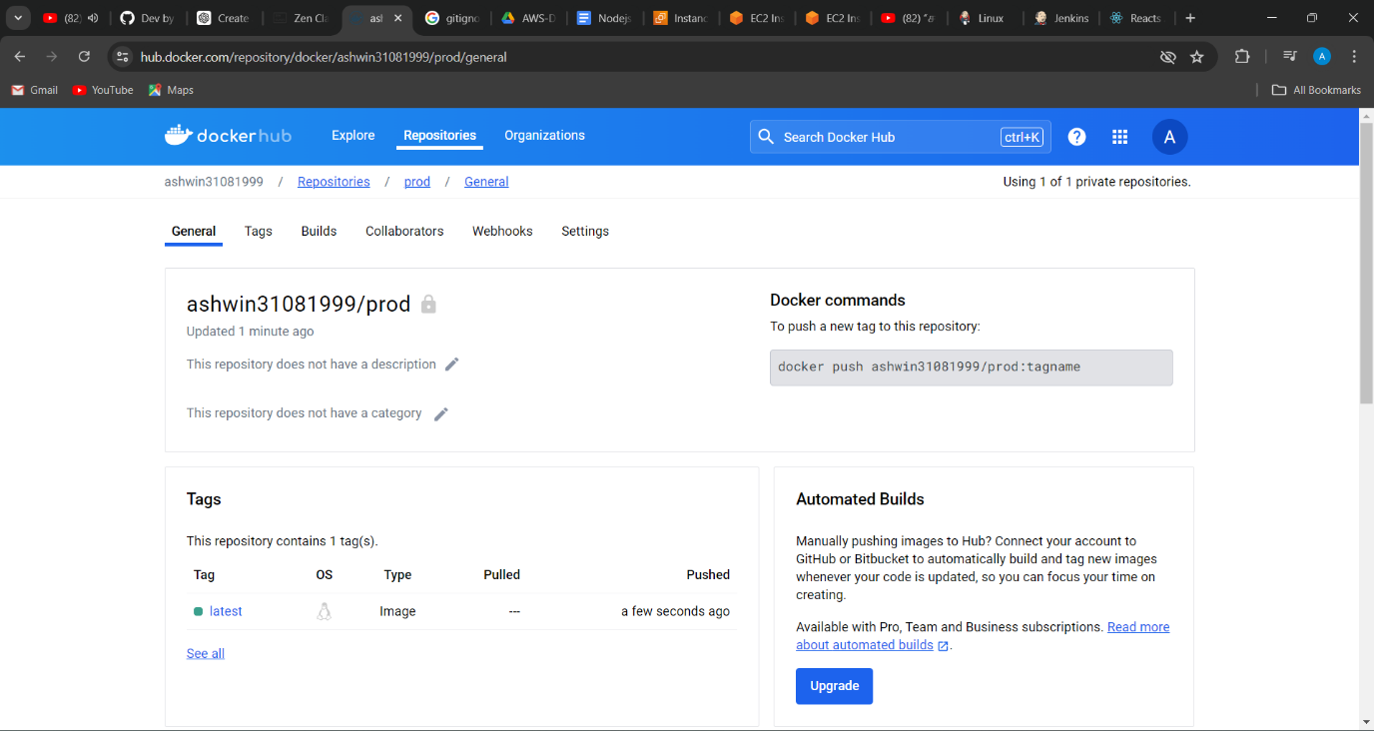

**23.Configuring the Prometheus file**

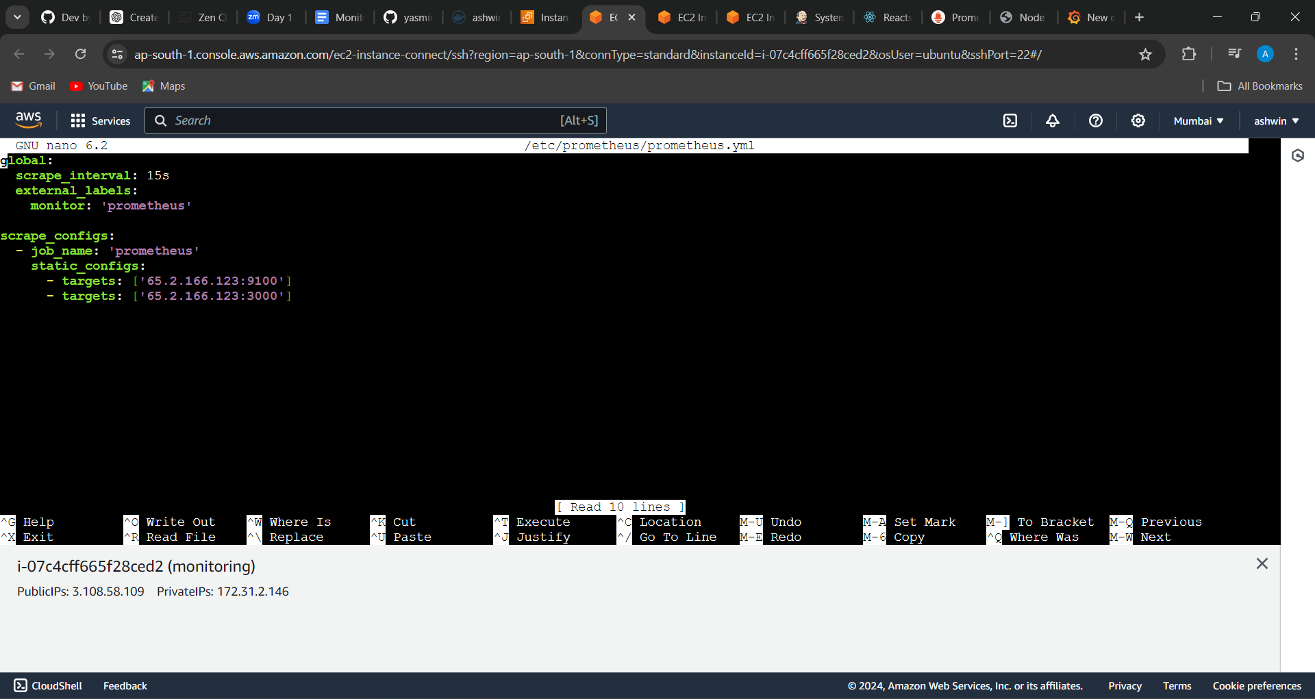

**24. Monitoring output using Grafana**

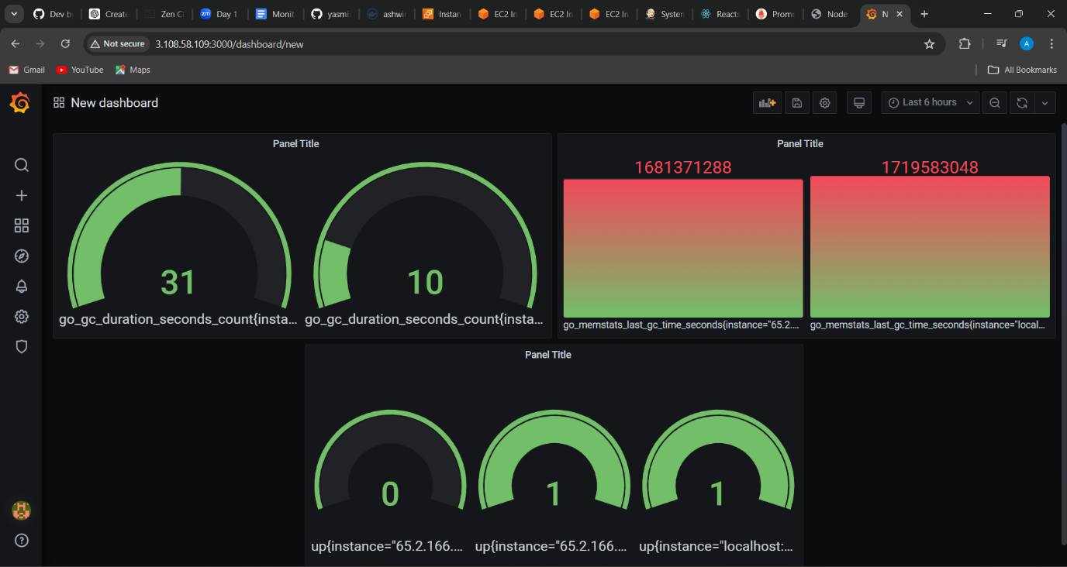

**25. Monitoring using cloud watch**

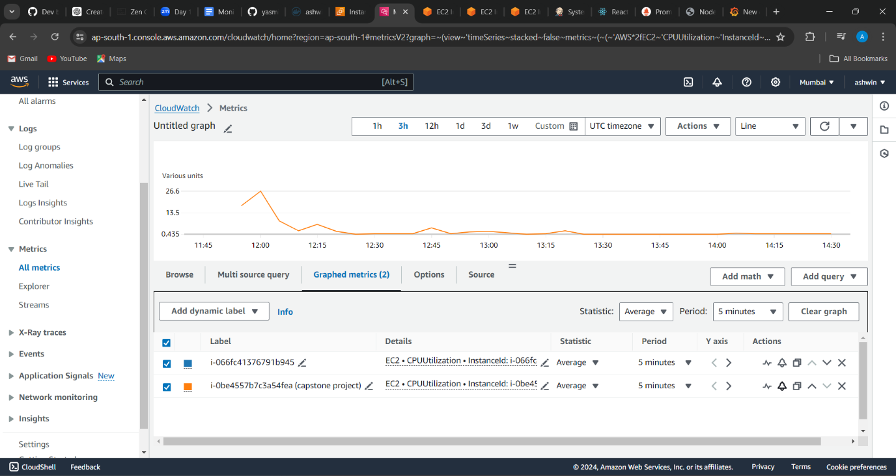

**26 Setting an alarm to get notified via email**

